**Aim:** Creating Geospatial feature maps in Tableau using Geospatial Data.

**Theory:**

Geospatial data is **data about objects, events, or phenomena that have a location on the surface of the earth**. The location may be static in the short-term (e.g., the location of a road, an earthquake event, children living in poverty), or dynamic (e.g., a moving vehicle or pedestrian, the spread of an infectious disease).Here we have use **Estimate Dataset** to analyse the no of cases depending on the country.

**Steps:**

Connect to spatial files

In Tableau Desktop: click the New Data Source icon and select **spatial file**.

Navigate to the folder that contains your spatial data, select the spatial file you want to connect to, and then click **Open**.

**Output:**

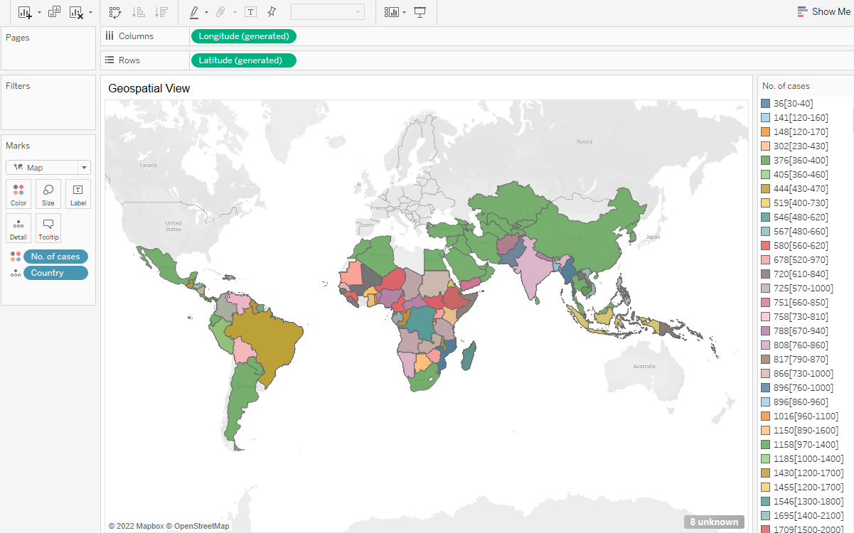

**Result:**

Saw how to analyse the data in the form of geographical area.